Accessing red alerts

- Log in to NHS pathways (eclipse) - it is important to use this link as it takes you to the secure link which will ensure NHS numbers are shown.

- Select Eclipse Live
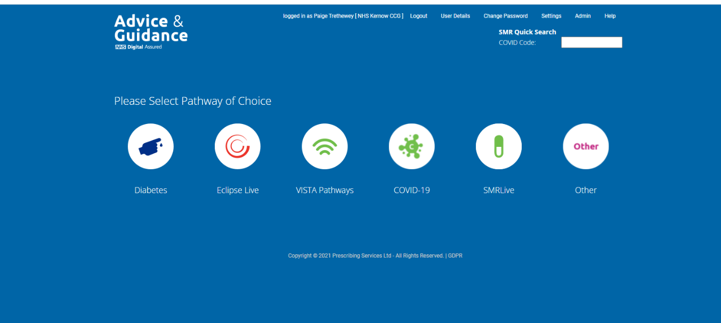

- Select Eclipse Radar 500 (red alerts), this will open the list of red alerts for the practice. Data is refreshed weekly on a Sunday; therefore, red alerts should be checked weekly by the practice to ensure patients are reviewed promptly.

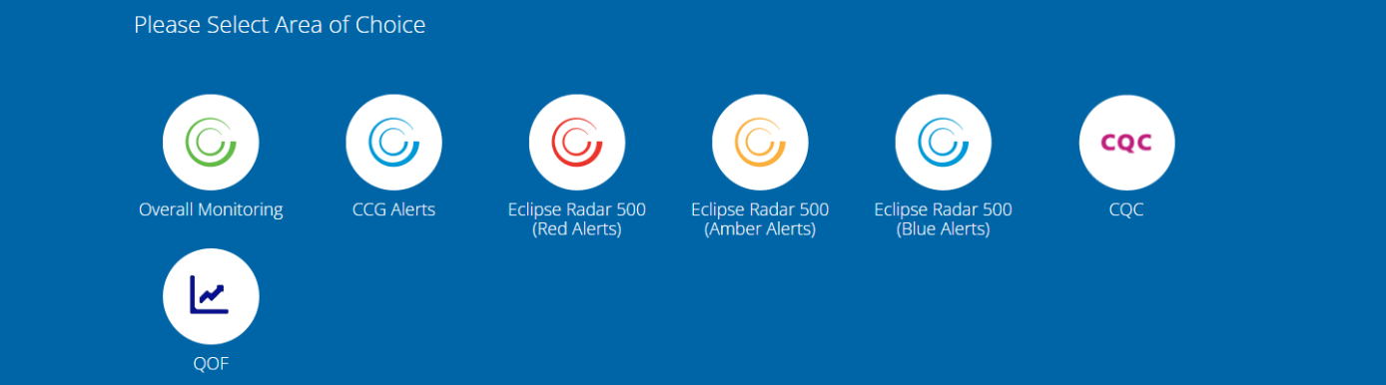

- You can also select alert breakdown to look at each alert individually and which patients have it, or alert breakdown by patient which shows all the alerts a patient has (this will include alerts from other categories, for example, amber and blue alerts). Clicking on these reports will download them to excel, by selecting ‘view’ on the alert breakdown excel download, this will display the NHS numbers.

- Once reviewed and actioned on the GP clinical system, please record this on Eclipse using the review or address buttons so that Eclipse can include this in their reporting to provide evidence of reviews. (For information: SMURF stands for Structured Medicines Use Review and Follow up- it allows you to see an overall view for each patient including medicines prescribed, observations and hospital admission information to support a structured medication review. However, as Eclipse is reviewing this function we would recommend only using Eclipse to establish the patient list, and using the GP clinical system to check clinical parameters and conduct the review).

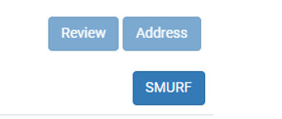

- For further help, the Radar500 patient safety alerts user guide can be found by clicking the help button on Eclipse in the top right corner.

